Name: Saad
Roll no: 076
Section: BSAI-3B
Subject: AI-Lab
Lab task: 3
Task 1: 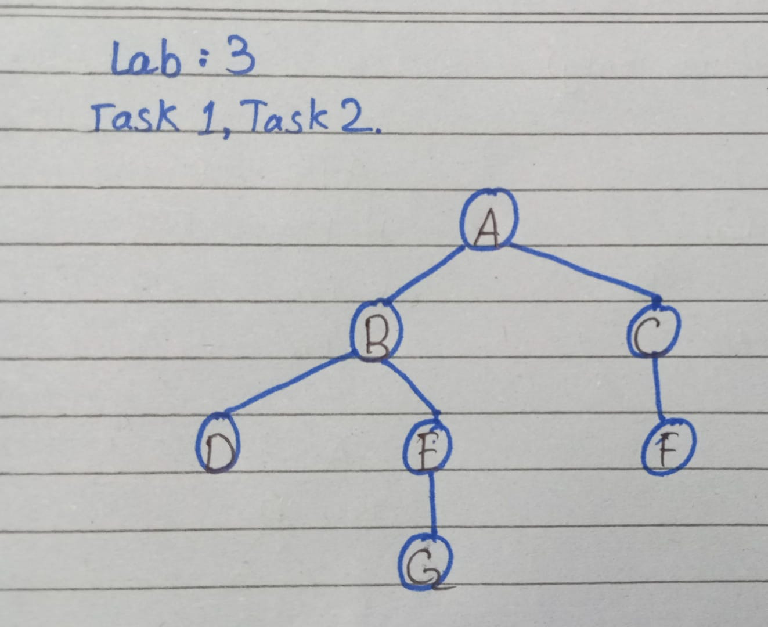
1 Breadth-First Search (BFS):
Starting with FIFO queue [(A, [A])] and explored set {A},
Step 1 pops A and enqueues [(B, [A,B]), (C, [A,C])] with seen set {A,B,C}.
Step 2 pops B and appends D and E to form [(C, [A,C]), (D, [A,B,D]), (E, [A,B,E])], while
Step 3 pops C and appends F to form [(D, [A,B,D]), (E, [A,B,E]), (F, [A,C,F])] with seen set {A,B,C,D,E,F}. Step 4 pops leaf D leaving [(E, [A,B,E]), (F, [A,C,F])],
Step 5 pops E and enqueues goal G to yield [(F, [A,C,F]), (G, [A,B,E,G])],
Step 6 pops leaf F, and Step 7 pops G to finish with path A -> B -> E -> G and visit order A, B, C, D, E, F, G.
2 Depth-First Search (DFS):
Starting with LIFO stack [(A, [A])] and an empty explored set,
Step 1 pops A and pushes reversed neighbors C then B to get [(C, [A,C]), (B, [A,B])].
Step 2 pops top node B and pushes reversed neighbors E then D to form [(C, [A,C]), (E, [A,B,E]), (D, [A,B,D])], and
Step 3 pops leaf D leaving [(C, [A,C]), (E, [A,B,E])].
Step 4 pops E and pushes G to produce [(C, [A,C]), (G, [A,B,E,G])], and
Step 5 pops G to return path A -> B -> E -> G with visit order A, B, D, E, G. Reversing the neighbor list before pushing places the leftmost neighbor on top of the stack, keeping traversal left-to-right and skipping C and F.
Output :
BFS: A ['A'] []
BFS: B ['A', 'B'] [('C', ['A', 'C'])]
BFS: C ['A', 'C'] [('D', ['A', 'B', 'D']), ('E', ['A', 'B', 'E'])]
BFS: D ['A', 'B', 'D'] [('E', ['A', 'B', 'E']), ('F', ['A', 'C', 'F'])]
BFS: E ['A', 'B', 'E'] [('F', ['A', 'C', 'F'])]
BFS: F ['A', 'C', 'F'] [('G', ['A', 'B', 'E', 'G'])]
BFS: G ['A', 'B', 'E', 'G'] []
['A', 'B', 'E', 'G']
DFS: A ['A'] []
DFS: B ['A', 'B'] [('C', ['A', 'C'])]
DFS: D ['A', 'B', 'D'] [('C', ['A', 'C']), ('E', ['A', 'B', 'E'])]
DFS: E ['A', 'B', 'E'] [('C', ['A', 'C'])]
DFS: G ['A', 'B', 'E', 'G'] [('C', ['A', 'C'])]
['A', 'B', 'E', 'G']
Task 2:
1 DLS & IDDFS:
With root A at depth 0, standalone DLS and IDDFS return CUTOFF at limit 0 (visiting [A], 1 expansion), CUTOFF at limit 1 (visiting [A, B, C], 3 expansions, 4 cumulative in IDDFS), and CUTOFF at limit 2 (visiting [A, B, D, E, C, F], 6 expansions, 10 cumulative). At limits 3 and 4, both return FOUND with path A -> B -> E -> G after visiting [A, B, D, E, G] (5 expansions at limit 3, totaling 15 cumulative IDDFS expansions with 8 repeated visits across 7 unique nodes). Limits 1 and 2 return CUTOFF rather than FAILURE because unvisited nodes still exist past the depth bound (D, E, F at limit 1, and G behind E at limit 2).
2 Repeated State Evaluations vs. Memory Retention:
From limit 0 to 3, IDDFS runs 15 total expansions compared to 7 in BFS because shallow nodes are re-expanded on each pass (A four times, B and C three times, D and E twice) using a path-local cycle check (neighbor in path). While BFS holds the entire frontier layer in memory at O(b^d) space, IDDFS clears its call stack after every depth limit to stay within O(b * d) linear space. This trades minor repeated work near the root for much lower memory usage on deep trees.
Output:
DLS 1 ('CUTOFF', None)
DLS 2 ('CUTOFF', None)
DLS 3 ('FOUND', ['A', 'B', 'E', 'G'])
DLS 4 ('FOUND', ['A', 'B', 'E', 'G'])
IDDFS 1 ('CUTOFF', None, [0, 1])
IDDFS 2 ('CUTOFF', None, [0, 1, 2])
IDDFS 3 ('FOUND', ['A', 'B', 'E', 'G'], [0, 1, 2, 3])
IDDFS 4 ('FOUND', ['A', 'B', 'E', 'G'], [0, 1, 2, 3])
Task 3:
1 Weighted Topology & Comparative Results:
For the weighted test, we add corridor C -> G with cost 10 alongside A -> B = 1, B -> D = 1, B -> E = 1, E -> G = 1, A -> C = 2, and C -> F = 1. Running BFS on this graph returns the 2-hop path A -> C -> G with a total cost of 12 (2 + 10) and visit order A, B, C, D, E, F, G. Running UCS returns the 3-hop path A -> B -> E -> G with a total cost of 3 (1 + 1 + 1), popping nodes in cost order A(0), B(1), C(2), D(2), E(2), F(3), G(3).
2 BFS vs. UCS:
BFS only finds the cheapest path when all edges have equal cost because its FIFO queue sorts paths by hop count and marks G as seen as soon as C is expanded at depth 1, ignoring the cheaper path through E. UCS finds the lowest-cost path by sorting frontier entries (cost, node, path) in a min-heap and waiting until a node is popped to mark it visited or check for the goal. Even though C pushes (12, G, [A,C,G]) first, E is popped at cost 2 and pushes (3, G, [A,B,E,G]), so the min-heap pops G with cost 3 first.
Output:
BFS: A ['A'] []
BFS: B ['A', 'B'] [('C', ['A', 'C'])]
BFS: C ['A', 'C'] [('D', ['A', 'B', 'D']), ('E', ['A', 'B', 'E'])]
BFS: D ['A', 'B', 'D'] [('E', ['A', 'B', 'E']), ('F', ['A', 'C', 'F']), ('G', ['A', 'C', 'G'])]
BFS: E ['A', 'B', 'E'] [('F', ['A', 'C', 'F']), ('G', ['A', 'C', 'G'])]
BFS: F ['A', 'C', 'F'] [('G', ['A', 'C', 'G'])]
BFS: G ['A', 'C', 'G'] []
Weighted BFS: ['A', 'C', 'G'] Cost: 12
UCS: ['A', 'B', 'E', 'G'] Cost: 3 Verified: 3 Order: [('A', 0), ('B', 1), ('C', 2), ('D', 2), ('E', 2), ('F', 3), ('G', 3)]

Edge Cases:
In my tests, start == goal (A to A) stops right away with path ['A'] and cost 0, unreachable goals (A to Z, D to G) return None or FAILURE, and cycles (B -> A, E -> A) finish cleanly via seen sets and path-local checks. Also, a global visited set in DLS blocks shorter paths in other branches, while negative weights break UCS after a node is closed.
Limitations:
On a real rescue robot, BFS and UCS keep every frontier node in memory at O(b^d), which quickly fills up onboard RAM in large buildings. IDDFS saves memory with O(b * d) space, but path-local checks re-visit the same rooms many times in grid maps. Also, none of these algorithms use direction heuristics, so UCS searches blindly in all directions.
Reflection:
I learned that getting the same path (A -> B -> E -> G) hides very different frontier behavior, and I will use BFS for unweighted graphs, IDDFS for low memory, and UCS when edges have travel costs. In Task 3, it surprised me that BFS and UCS visited the same 7 nodes in order yet returned costs 12 vs 3; next time I will filter worse heap duplicates early.

